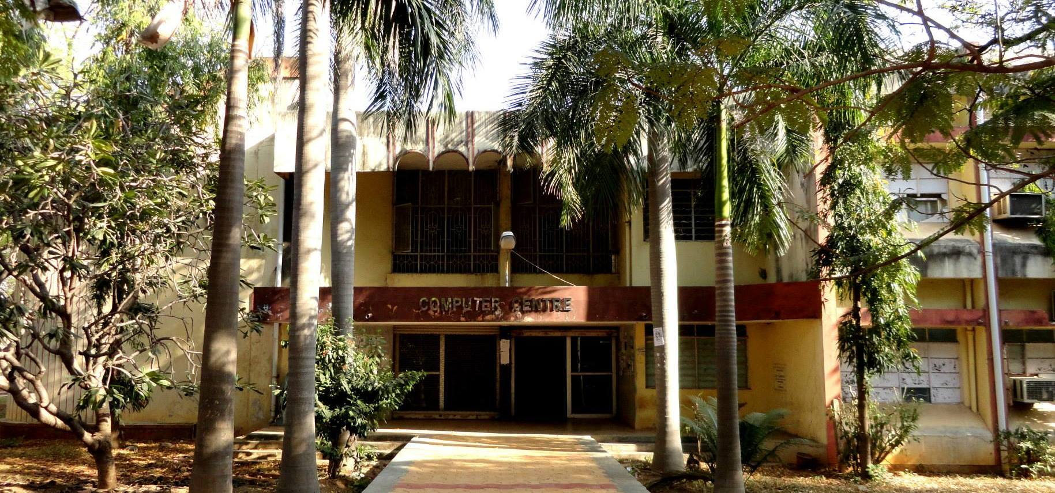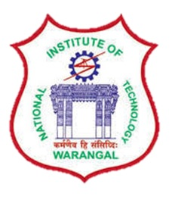

**National Institute of Technology, Warangal**

**Department of Computer**

**Science & Engineering**

***MISSION-***

* Imparting quality education through well-designed curriculum in tune with the challenging software needs of the industry.
* Providing state-of-art research facilities to generate knowledge and develop technologies in the thrust areas of Computer Science and Engineering.
* Developing linkages with world class organizations to strengthen industry-academia relationships for mutual benefit.

***VISION-***

Attaining global recognition in Computer Science & Engineering education, research and training to meet the growing needs of the industry and society.

* **B. Tech**
* **MCA**
* **M. Tech**
* **Ph.D.**



***Areas of Research-***

* Bio-Informatics / Computer Networks / Cryptanalysis / Database Technologies Data Mining / IDS / Distributed Systems / Information Security / Machine Learning / Neural Networks and Soft Computing / Parallel Processing / Rough and Fuzzy systems / Software Engineering / Secure Multi-party Computations / Mobile Computing, Wireless Ad-hoc and Sensors Net-works, Cyber Physical Systems and Security / Computational Neuroscience



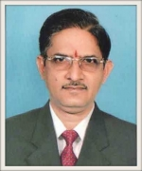

***Head of Department-***

Dr. R.B.V. Subramaanyam

#### **Education:  M. Tech. (IIT Kharagpur),**

#### **Ph.D. (IIT Kharagpur)**

***CSEA-***

**Computer Science and Engineering Association (CSEA)**

* CSEA has been functioning over the years in the department of Computer Science & Engineering with the objectives of promoting student activities for organizing and participating in co-curricular activities by the students of the Department.
* All the students of CSE department are members of CSEA.
* The events conducted by CSEA promote Organizing capabilities and communication skills of students in addition to developing the technical knowledge.

***Labs-***

* Computing laboratory
* Data Engineering Laboratory
* Open Source Development Laboratory
* Software Engineering Laboratory
* Wireless and Security Laboratory